

ASSET VERIFICATION AND RECORDING TOOL KIT


Plot 31, Bukoto Street
P.O Box 7657, Kampala, Uganda
+256 (0) 39 2000216/0772525235
email: cpa@cpa.ug

www.cpa.com

August to September 2026

VERIFICATION DETAILS

NAME OF THE REGION: | EASTERN REGION
SUB-REGION: | BUSOGA
Name of Local Government | NAMUTUMBA DISTRICT LOCAL GOVERNMENT
 | EASTERN REGION
VERIFIER PARTICULARS
Full name | BUSOGA
Contact/ email and Telephone
 | MAYUGE DISTRICT LOCAL GOVERNMENT
Supervisor/ Sub team leader
Name | EASTERN REGION
Contact
 | BUSOGA
Date of submission

HEALTH CENTRES
INFORMANT INTERVIEW/DISCUSSION GUIDE (INCHARGE OR RESPONSIBLE PERSON)

Name of Health Centre: NANGONDE HEALTH CENTRE

1a | Does the Facility have a record of all assets provided under UgIFT.  (Obtain a record and verify if it has the costs and numbers supplied | NO,
1b | If Not ask how many were supplied and when.

2 | How does this facility Maintain (repair/service/replace) the assets provided under Ugift  - Minor maintenance such as cleaning, servicing, simple repairs and replacement of basic parts is done by the facility staff of nangonde itself. However, for sophisticated and complex medical equipment such as BP machine can not be handled by the facility. A report is made to the DHO. The DHO then organizes the regional medical equipment workshop team

3 | Does the facility take regular record about functionality/ or breakdown of the assets provided? | Yes,  - they have an inventory book where they record the break downs

4 | How has the UgIFT support helped in service delivery in the area, any issues, challenges and any recommendations for better program implementation. | BENEFITS  - It has improved the quality of health service delivery at Nangonde sub county because most of the admissions e.g maternity  - It has increased the capacity of the facility to handle more patients at once i.e they can handle pediatrics, adults and pregnant mothers  - It has also improved infection prevention and control through provision of sterilization trays and trolleys  - It has motivated health workers through better accommodation and working environment  CHALLENGES  - The facility in charge lacks an office  - Inadequate staffing. The number of staff at Nangonde is not enough compare to the increasing number of equipment, new blocks and patient load that came with ugift support  - The assets received by this facility is honestly small compared to other facilities yet they the facility serves a big number patients in the community  - Insecurity. It was reported by our respondent that the local people are war mongers. A quick one on their hostility, they once in attacked the facility violently demanding for the resignation of the then in charge. This has left many of the facility staff serving in fear thus affecting the effectively delivery of the necessary services to the patients  RECOMMENDATION.  - Consider supplying adequate assets to Nangonde health center as they have a good number of patients to attend to.  - Build more staff quarters to provide accommodation to the facility staff  - Build the in charge’s office as she lacks one.  - She is presently occupying a room in the maternity ward

PROCEED TO VERIFICATION AFTER THIS DISCUSSION

Health centre checklist

NAME OF LG: NAMUTUMBA DISTRICT NAME OF HEALTH FACILITY: NANGONDE HEALTH CENTRE III

Equipment/ Item | Department | Asset Number | Item  Description | Life in Months | Tag Number ( engrave no.) | Date Of Purchase | Date Placed In Service | Recoverable cost | Cost | Acc Dep Cost | Net Book Value | Ytd Deprn | Equipment status | Remarks
B.P. Machine, Digital | 2 |  | It is white in color model 2088C with a black surface and a rectangular screen |  | Not engraved |  |  |  |  |  |  |  | Functioning | 1 Received and in use
B.P. Machine (Aneroid wall mounted) | health |  | It has a gauge, white in color, with a black metallic base mounted on the wall |  | Not engraved |  |  |  |  |  |  |  | Functioning | 2 Received, verified and in use
Autoclave 20 Liters.,Duo Operated | health |  | Silver cylindrical stainless bowl with a round top and black handles with a gauge. |  | Not engraved |  |  |  |  |  |  |  | Functioning | 1 Received and in use
Bowl, Kick | health |  | Standard silver steel medical bowl with mobile kick stand. |  | Not engraved |  |  |  |  |  |  |  | Functioning | 2 received, verified and all in use
Bowl Stand | health |  | Standard double bowl size with 2 bowls |  | Not engraved |  |  |  |  |  |  |  | Functioning | 3 received, verified and all in use
Counting chamber Neubauer- Improved | health |  | it’s a clear glass improved device with silver etched grid and 2 transparent covers slips in blue plastic case. |  | Not engraved |  |  |  |  |  |  |  | Functioning | 2 received, verified and all in use
Cupboard Steel, Lockable | health |  | standard grey metallic steel cupboard with lockable double door and adjustable shelves. |  | Not engraved |  |  |  |  |  |  |  | Functioning | 2 Received and in use
ESR Stand | health |  | A standard metallic grey metal with adjustable leveling for holding tubes. |  | Not engraved |  |  |  |  |  |  |  | Functioning | 1 Received and in use
Examination Couch | health |  | A standard grey metallic frame table with black mattress on top, adjustable with a handle. |  | Not engraved |  |  |  |  |  |  |  | Functioning | 2 received and in use
Examination light,LED | health |  | A metallic stand light with bright white led light, adjustable head used for examining patients |  | Not engraved |  |  |  |  |  |  |  | Functioning | 2 received, verified and all in use
Glucometer | health |  | A small black portable machine with screen and test strips . |  | Not engraved |  |  |  |  |  |  |  | Functioning | 3 Received and in use
Haemoglobin Meter, Digital | health |  | A small portable handheld device, white and grey plastic with screen on top. |  | Not engraved |  |  |  |  |  |  |  | Functioning | 2 received, verified and all in use
Height Meter | health |  | A tall vertical metallic stand, silver in color with flat base and sliding head and height scale. |  | Not engraved |  |  |  |  |  |  |  | Functioning | 1 Received and in use
Instrument Trolley | health |  | Medium sized, Grey in color with 2 compartments , the lower one bigger than the upper one |  | Not engraved |  |  |  |  |  |  |  | Functioning | 2 received, verified and all in use
Mid upper arm tape |  |  |  |  | Not engraved |  |  |  |  |  |  |  | Functioning | 4 Received and in use
Otoscope | health |  | A small handheld black plastic device, torch like shape with light head on top and pocket sized. |  | Not engraved |  |  |  |  |  |  |  | Functioning | 1 Received and in use
Patient Screen | health |  | A metallic folding frame, blue cloth, 3- panel, stands on 4 wheels. |  | Not engraved |  |  |  |  |  |  |  | Functioning | 4 Received and in use
Patient Trolley | health |  | A rectangular stainless steel frame, silver metallic with 2 selves, 4 wheels with 2 lockable, medium sizes with a push handle. |  | Not engraved |  |  |  |  |  |  |  | Functioning | 1 received, verified and all in use
Refrigerator, Basic | Health |  | Medium size upright electric device, grey metallic outer body with single door and selves. |  | Not engraved |  |  |  |  |  |  |  | Functioning | 1 Received and in use
Stethoscope | Health |  | Black in color with 2 rubber flexible tube |  | Not engraved |  |  |  |  |  |  |  | Functioning | 4 Received and in use
Stop Watch | health |  | Handheld digital timer with start, stop and reset function. |  | Not engraved |  |  |  |  |  |  |  | Functioning | 2 received and verified
Stretcher | Health |  | It’s a bed with 4 black wheels ,two rails and black soft sponge |  | Not engraved |  |  |  |  |  |  |  | Functioning | 1 received, verified and all in use
Stove, Gas | health |  | It’s a burner gas with a gas cylinder and regulator. |  | Not engraved |  |  |  |  |  |  |  | Functioning | 1 Received and in use
Weighing Scale with Height Meter, Adult | health |  | Tall, White in color, automated with a height and a gauge. With a black rectangular base in nature |  | Not engraved |  |  |  |  |  |  |  | Functioning | 2 received, verified and all in use
Weighing Scale, Infant |  |  | It’s a digital scale with a small white plastic tray |  | Not engraved |  |  |  |  |  |  |  | Functioning | 2 Received and in use
Weighing Scale, Toddler | health |  | A standard white and light blue electronic device with a large tray, LCD display, height rod. |  | Not engraved |  |  |  |  |  |  |  | Functioning | 2 received, verified and all in use
Wheel Chair |  |  | Medium, Black in color, foldable chair, with 2 back wheels, 2 foot pads and 2 handles |  | Not engraved |  |  |  |  |  |  |  | Functioning | 2 received, verified and all in use
Medical Waste Bin | health |  | Medium 20litre, plastic bin with a footpad. |  | Not engraved |  |  |  |  |  |  |  | Functioning | 3 Received and in use
Wall Clock | health |  | A round white dial device, black numbers and hands, plastic body with glass cover and wall hanging. |  | Not engraved |  |  |  |  |  |  |  | Functioning | 4 received, verified and all in use
Diagnostic Equipment Set for OPD | health |  | Small portable, silver metal tools for general OPD examination. |  | Not engraved |  |  |  |  |  |  |  | Functioning | 2 Received and in use
Glassware Set, Laboratory, Basic | health |  | Small, transparent glass containing, beakers, test tubes, measuring cylinder, slides and petri dishes |  | Not engraved |  |  |  |  |  |  |  | Functioning | 2 received, verified and all in use
Instrument Set, Dressing |  |  | Small set, sliver, metallic tray containing scissors, forceps, needle holder. |  | Not engraved |  |  |  |  |  |  |  | Functioning | 2 Received and in use
Instrument Set, Basic ENT |  |  | It’s a set, silver in color stainless steel with standard size instruments. |  | Not engraved |  |  |  |  |  |  |  | Functioning | 2 received and all in use
Pulse Oximeter, Hand held | health |  | Small portable size, white and blue color with finger probe for measuring oxygen saturation and pulse |  | Not engraved |  |  |  |  |  |  |  | Functioning | 2 Received and in use
Bed, Adult Patient with Mattress | health |  | Standard single beds with black mattress, grey metallic frame and manually adjustable. |  |  |  |  |  |  |  |  |  | Functioning | 10 Received and 8 in use
Bed, Pediatric Patient, With Mattress | health |  | White in color with blue soft sponge mattress, white metallic frame and side rails. |  | Not engraved |  |  |  |  |  |  |  | Functioning | 5 Received and in use
Cupboard, Instrument | health |  | A tall upright metallic device, white and grey, double glass doors on top, double metal doors. |  | Not engraved |  |  |  |  |  |  |  | Functioning | 1 Received and in use
Resuscitator Manual, Infant, with all Mask sizes | health |  | A small handheld silicone device, transparent bag with blue valve. |  | Not engraved |  |  |  |  |  |  |  | Functioning | 15 Received and in use
Resuscitator Manual, Adult, with all mask sizes | health |  | A light handheld silicone device, transparent bag with blue valve. |  | Not engraved |  |  |  |  |  |  |  | Functioning | 15 received, verified and 6 all in use
Bubble CPAP | health |  | Medium whit and blue electronic device with tubes and water bottle to help newborns with breathing. |  | Not engraved |  |  |  |  |  |  |  | Good and functional | 2received, verified.1 in use
Suction Apparatus, (Electric) | health |  | It is an electric pump, White, with 2 bags of water and a guage.  Model COO1-A with 4 wheels |  | Not engraved |  |  |  |  |  |  |  | Functioning | 1 received, verified and all in use
Nebulizer, Ultrasonic |  |  | Small tabletops size with white color ultrasonic with adult and child mask set |  | Not engraved |  |  |  |  |  |  |  | Functioning | 1 Received and in use
Oxygen Concentrator, Duo Flow |  |  | Medium size, Grey, 2 handles on top and a cylinder also on top. With outlets and wheels at the bottom |  | Not engraved |  |  |  |  |  |  |  | Functioning | 2 Received and in use
Disinfection Buckets | health |  | A set of large plastic buckets, blue in color with lids. |  |  |  |  |  |  |  |  |  | Functioning | 6 Received and in use
Baby Cot | health |  | A small metallic infant bed device, white steel frame, with transparent sides on 4 wheels with mattress. |  | Not engraved |  |  |  |  |  |  |  | Functioning | 2 Received and in use
Diagnostic Equipment Set for Ward |  |  | A portable metric kit containing stethoscope, clinical thermometer, torch, and plastic materials. |  | Not engraved |  |  |  |  |  |  |  | Functioning | 1 received, verified and all in use
Hollow Ware Set, Ward | health |  | A large steel set, silver color containing kidney dish, bowl and tray of different sizes on a tray. |  | Not engraved |  |  |  |  |  |  |  | Functioning | 1 Received and in use
Instrument Set, Delivery | health |  | A medium steel set, silver color containing scissors, forceps, cord clamps, kidney dish in a steel tray. |  | Not engraved |  |  |  |  |  |  |  | Functioning | 3 Received and in use
MVA Kit | health |  | Small white plastic manual vacuum aspirator kit with syringe 4-12mm cannula for evacuation. |  | Not engraved |  |  |  |  |  |  |  | Functioning | 3 Received and in use
Stool, Laboratory | health |  | Standard size, high, silver with 5 wheels and black in color |  | Not engraved |  |  |  |  |  |  |  | Functioning | 1 Received and in use
Penguin Sucker | health |  | Small white rubber bulb for newborn suction. |  |  |  |  |  |  |  |  |  | Functioning | 3 received, verified and all in use
Fetoscope, Dopplar | health |  | Handheld pocket size, white in color with a screen, display and speaker. |  | Not engraved |  |  |  |  |  |  |  |  | 2 Received and in use
Bubble CPAP | health |  | Medium whit and blue electronic device with tubes and water bottle to help newborns with breathing. |  | Not engraved |  |  |  |  |  |  |  | Functioning | 2 received, verified and all in use
Centrifuge (Electric) | health |  | Small white plastic bench top small size digital machine |  | Not engraved |  |  |  |  |  |  |  | Functioning | 1 received, verified and all in use
Kangaroo Mother Care Chair | health |  | A large fabric reclining mother chair with silver metallic frame. |  | Not engraved |  |  |  |  |  |  |  | Functioning | 1 Received and in use
Radiant Infant Warmer |  |  | . |  | Not engraved |  |  |  |  |  |  |  | Functioning | 1 received, verified and all in use
Haemoglobin Meter, Sahli | health |  | Small black box kit, hand held with 2 tubes |  | Not engraved |  |  |  |  |  |  |  | Functioning | 2 Received and in use
Delivery Bed | health |  | It is a manually adjustable bed.  Model H7 with peach mattress and a drip stand, grey metallic frame for delivery position. |  | Not engraved |  |  |  |  |  |  |  | Functioning | 2 Received and in use
Examination light, LED | health |  | It is medium size, white in color, with mobile stand base and a led . |  | Not engraved |  |  |  |  |  |  |  | Functioning | 2 Received and in use
Instrument set, ENT Basic for HCIII | health |  | It’s a set stainless tray with a lid, silver and perforated containing equipment for ENT |  | Not engraved |  |  |  |  |  |  |  | Functioning | 2 received, verified and all in use
Office Chair | health |  | Black in color, swinging in nature with 5 black wheels |  | Not engraved |  |  |  |  |  |  |  | Functioning | 4 Received and in use
Desk | health |  | Wooden office desk with cabinet, brown in color.t |  | Not engraved |  |  |  |  |  |  |  | Functioning | 3 Received and in use
Filing Cabinet |  |  | Standard 4-drawer size, grey metallic color, |  | Not engraved |  |  |  |  |  |  |  | Functioning | 2 Received and in use
Non Residential Buildings
Water Tanks |  |  | cylindrical, one raise and one on ground
Main block |  |  | with men ward, pediatric ward, OPD ward, offices, maternity ward and the store
Hash pit, |  |  | it is a cemented circular pit
placenta pits |  |  | Square cemented pit with a square coffee brown metallic cover). |  | Engraved “placenta pit” |  |  |  |  |  |  |  | In use and  functioning
Pit latrines |  |  | (4 stances with a metallic door and coffee brown + yellow in color |  | Not engraved |  |  |  |  |  |  |  | functioning
Residential Buildings
Staff quarters |  |  | Coffee brown and yellow color block with 2 bed rooms.units. |  | Not engraved

ASSET VERIFICATION BRIEF REPORT
HEALTH CENTER: NANGONDE HEALTH III,

CONDUCTED BY
WANDERA SOLOMON AND KIYUBA SALIMU
Introduction.
This brief report presents the findings of the physical asset verification exercise conducted at NANGONDE HEALTH III. The team was warmly welcomed by the in charge Mrs. Kanda Sharifah and Mr. NAJIB MASAMBA (Clinical Officer) who was the focal person in this exercise
Findings.
- Most assets were not assigned to this facility and those that were, are not enough to facilitate smooth service delivery
- Key assets including all medical assets, furniture and buildings were physically verified and found present.
- Most of the facility assets were not engraved.
- All the items were found to be functional and in good physical condition. However, it was observed that some of the equipment are currently stored and not yet in active use. This is due to lack of patients that do require those particular assets e,g Bubble CPAP
- Limited storage space. The facility is facing a challenge of inadequate storage space for newly received equipment. This is because the facility receives assets from many other different funders or organizations
- The facility has inadequate accommodation for staff. The available staff quarters are not sufficient to accommodate all the critical staff required to be within the facility premises especially maternity and night duty staff. i.e only one block with 2 rooms

Challenges.
- Almost all the assets were not engraved thus making the verification exercise very hard because we could not establish whether what we verified was for Gift of not.
.

Recommandation.
- Consider supplying more assets to Nangonde HC III
- Limit the supply of many equipment and ensure needs based supply .The supply of equipment should be based on facility needs assessment and capacity.
- Immediate engraving of assets should be done immediately upon receipt with source of funding and asset codes for easy identification during verification.
- The focal persons should be fully oriented on all medical equipment to effective support verification and management.
- The district and DHO should always maintain and provide an update asset register during the verification.
- Consider construction of more staff quarters to accommodate and retain critical staff for effective 24hr service delivery.

Conclusion.
The asset verification exercise was successfully completed with full staff from Mr. Mr. NAJIB MASAMBA (Clinical Officer) . All critical assets were verified, are functional, in good condition and well handled.
Addressing storage and more equipment addition challenges at Nangonde Health Centre will greatly improve service delivery and asset management

Sample of Physical Verification Pictures.

The table below illustrates some physical status of the verified assets with photographic evidence.
Physical verification photos FOR NANGONDE HEALTH CENTRE III
NANGONDE HEALTH CENTRE GATE(UNDER CONSTRUCTION) | 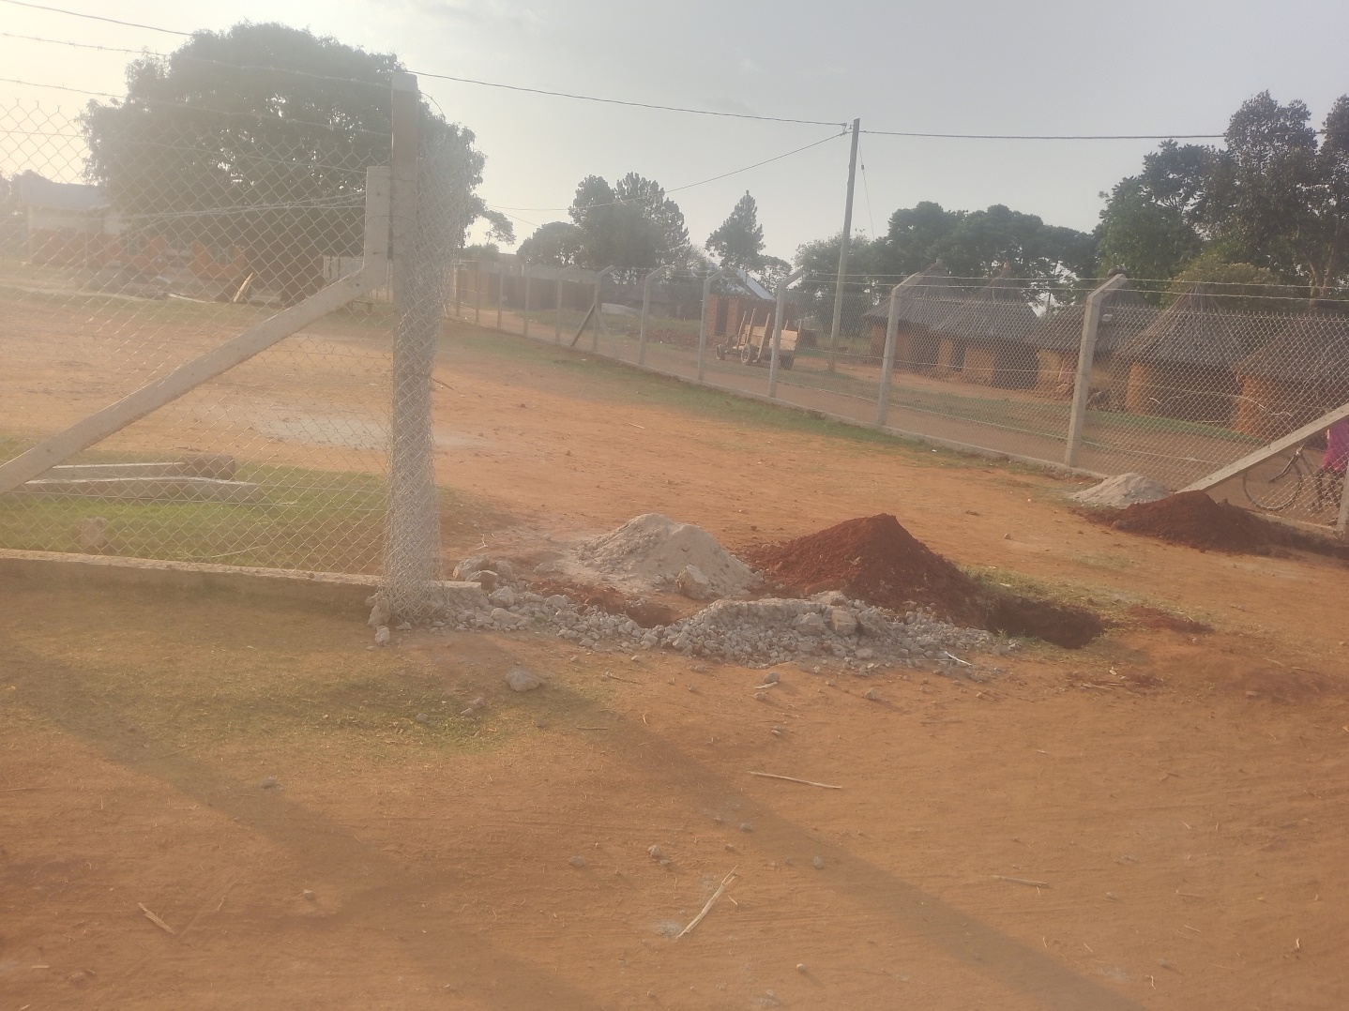
NANGONDE HEALTH CENTRE III SIGN POST | 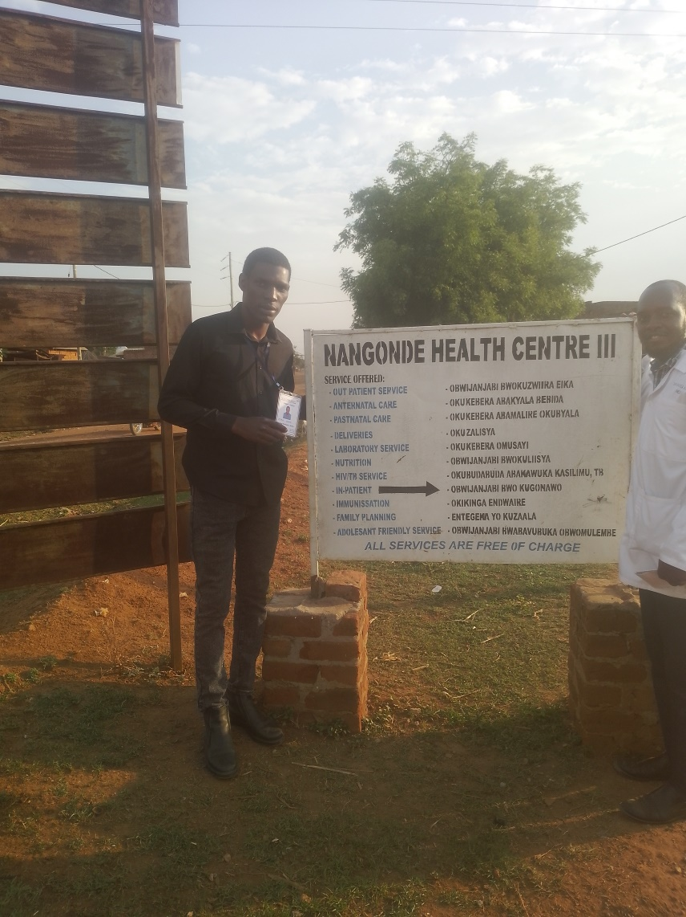

NANGONDE STORE | 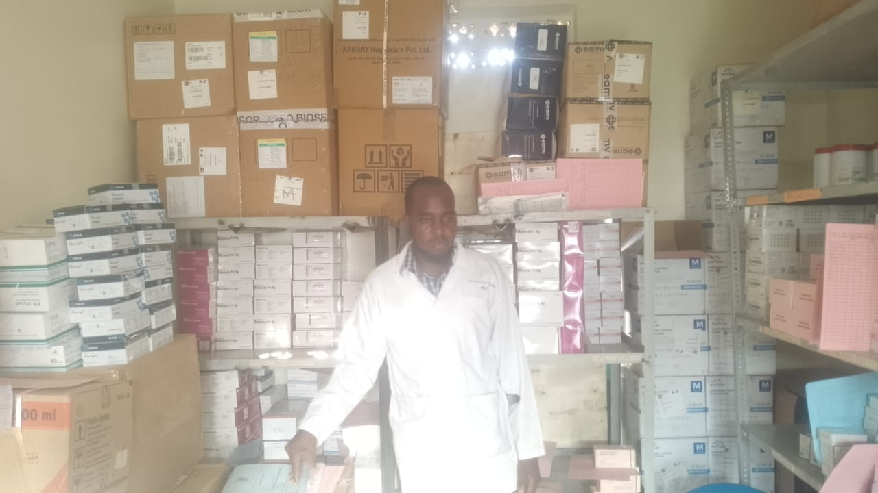
RADIANT INFANT WARMER  NOT ENGRAVED | 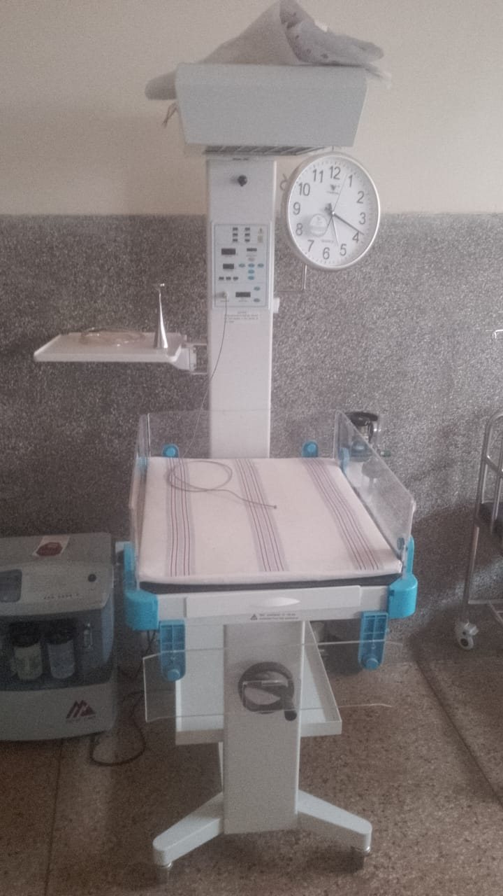
PATIENT TROLLEY  NOT ENGRAVED | 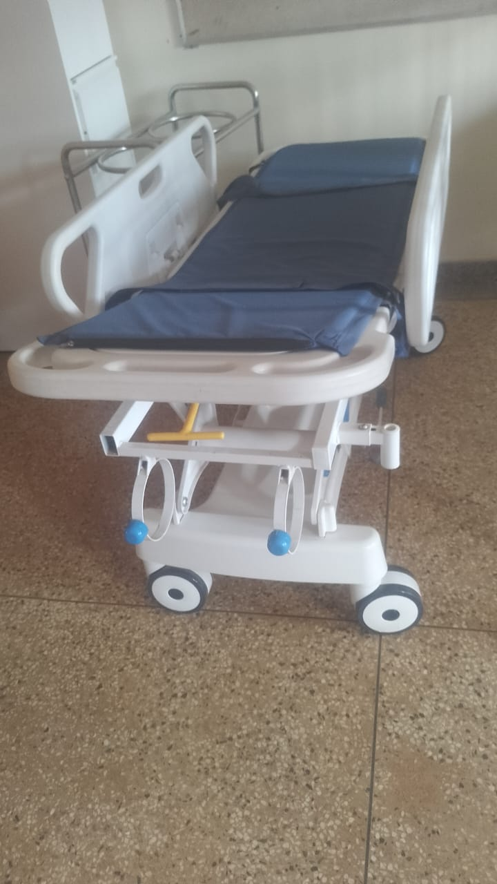
WEIGHING SCALE TODDLER  NOT ENGRAVED | 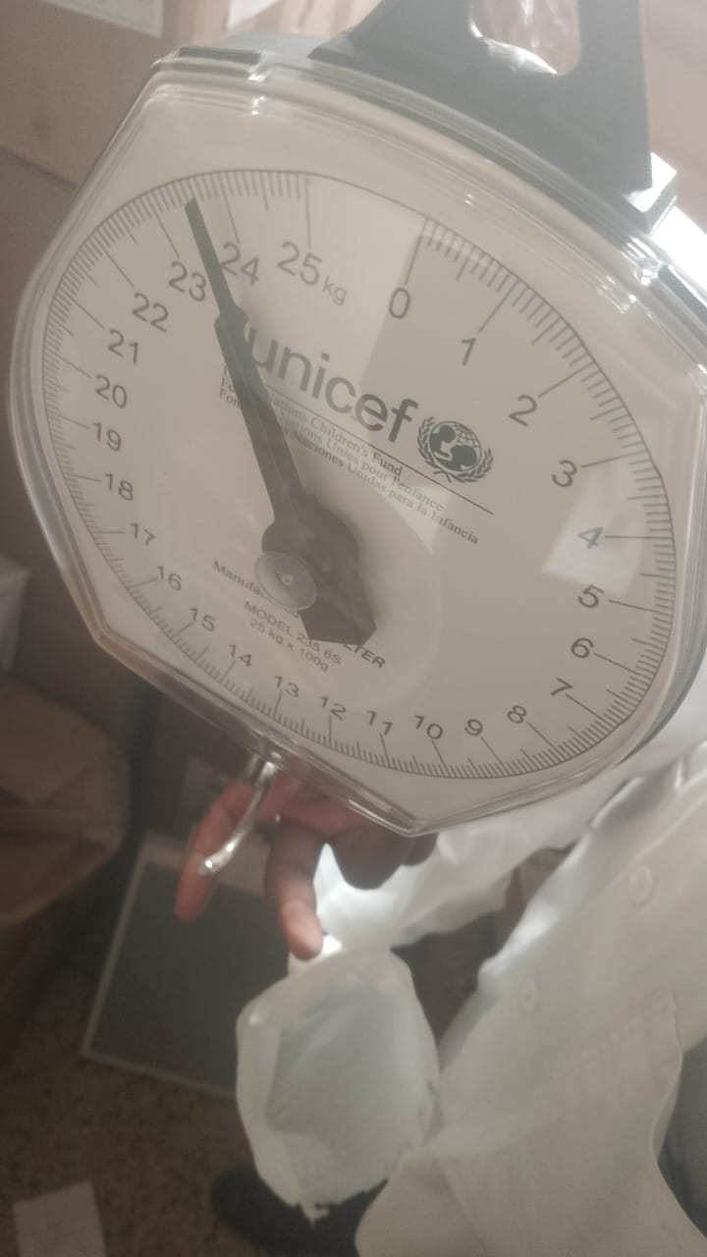

MICROSCOPE  NOT ENGRAVED | 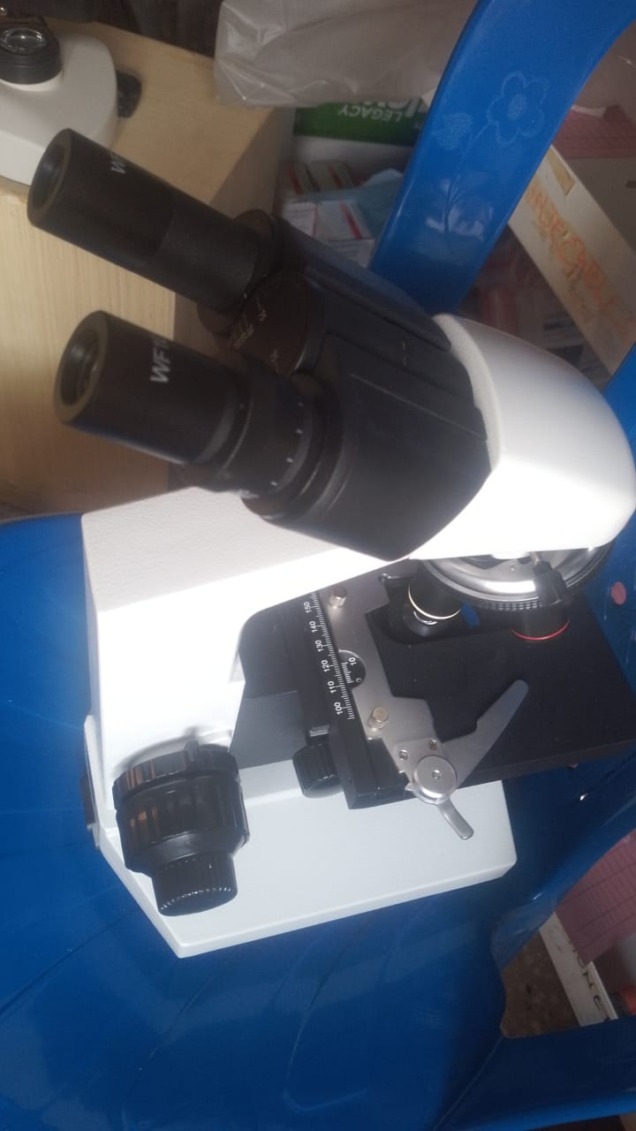
NUBLIZER  NOT ENGRAVED  AND NOT IN USE | 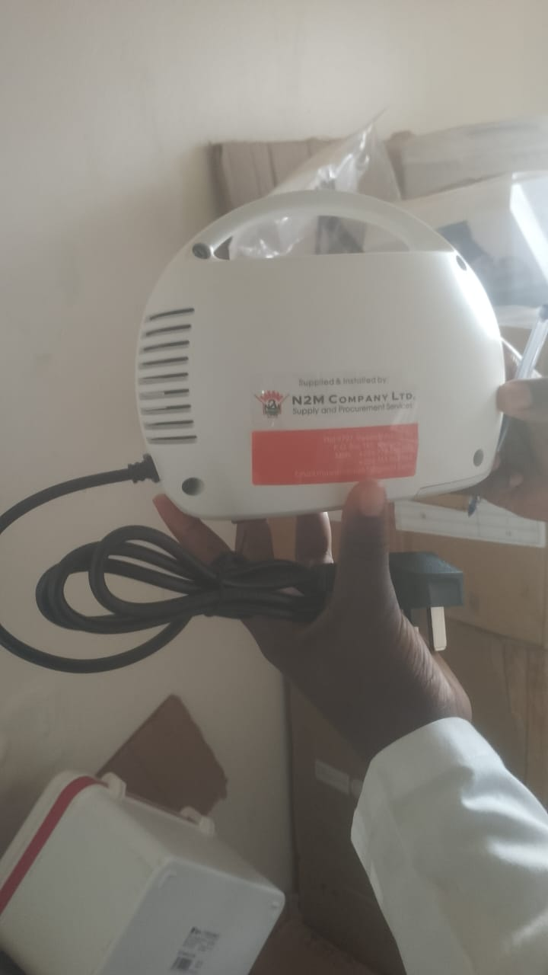
SUNCTION APPARATUS  NOT ENGRAVED | 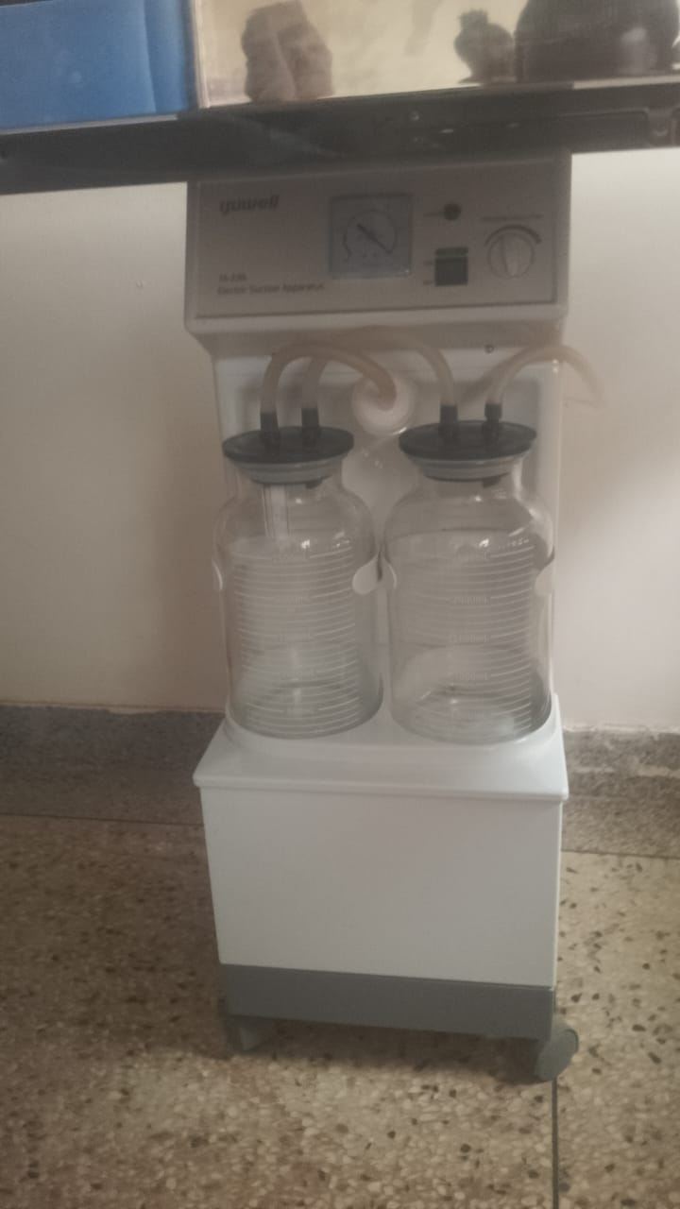
AUTOCLAVE  NOT ENGRAVED | 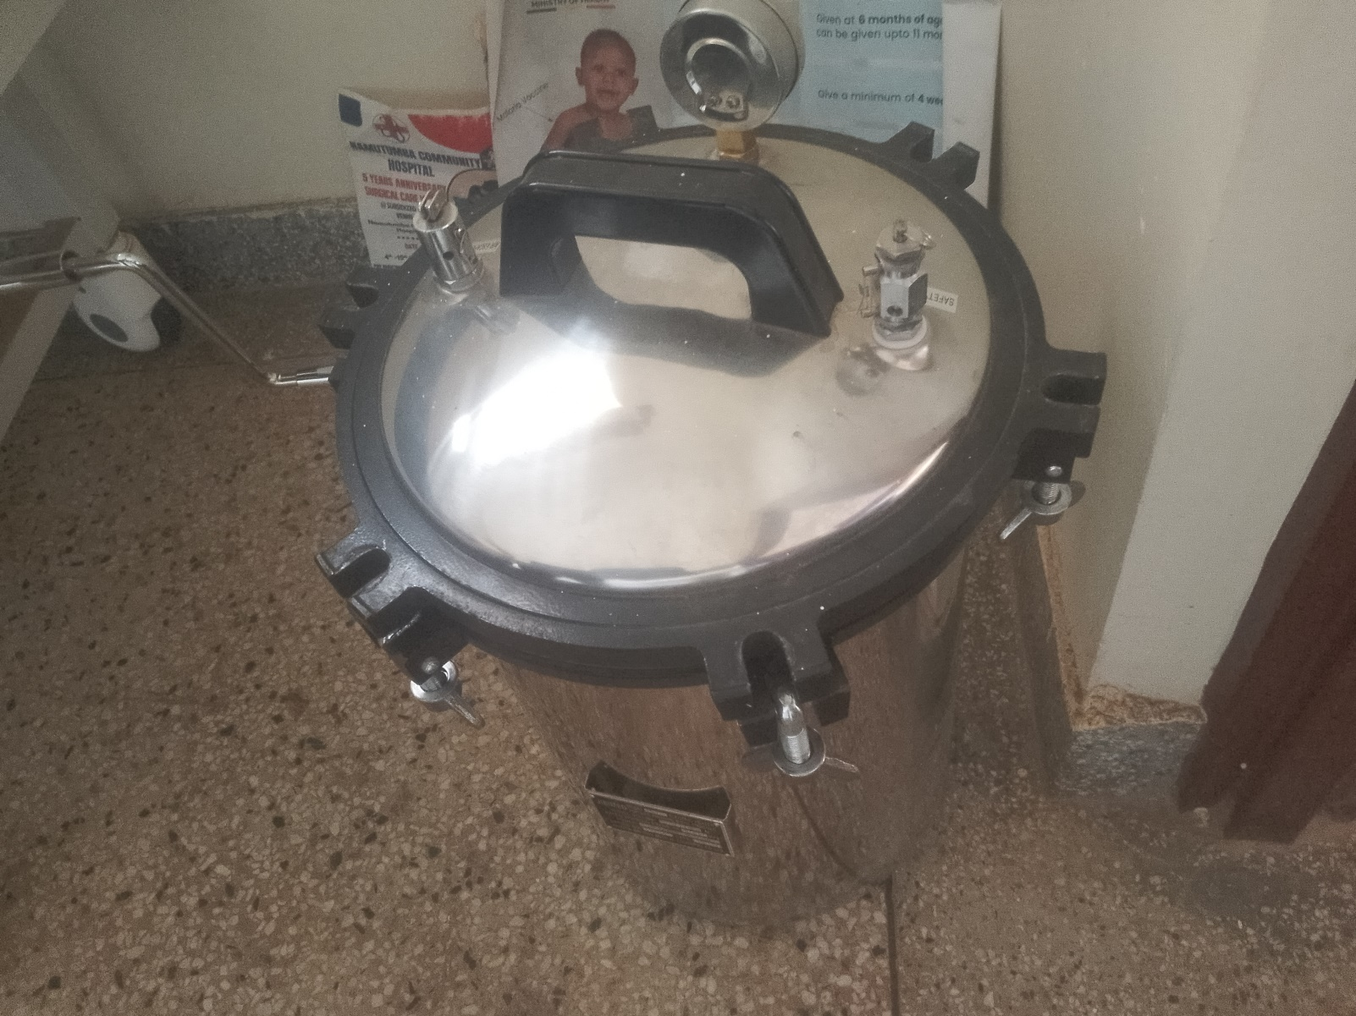
OXYGEN CONCETRATOR | 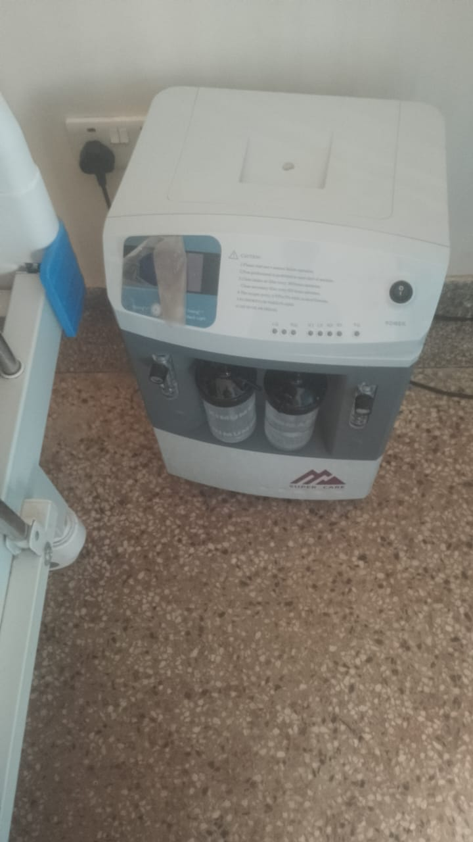
DISINFECTION BUCKETS | 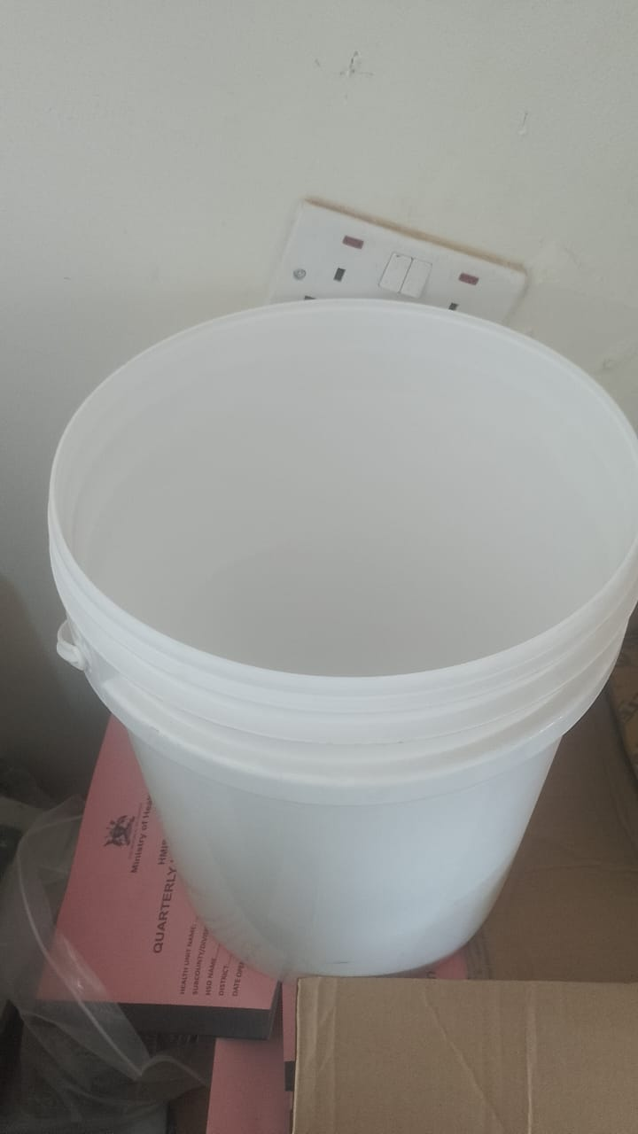
 | 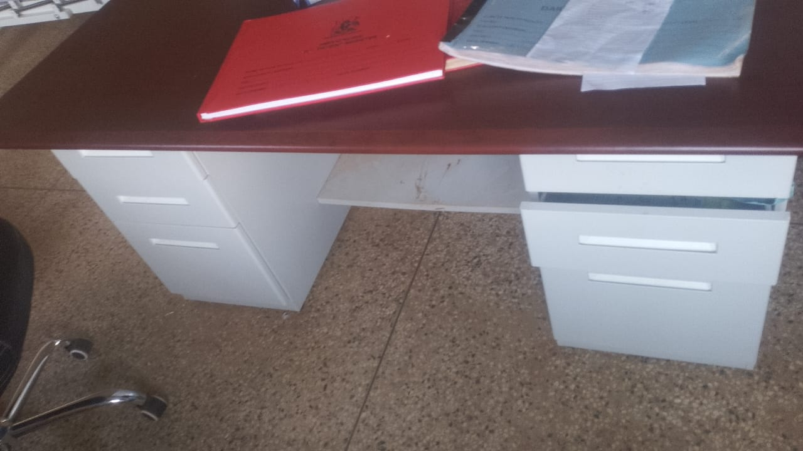
BENCHES  ENGRAVED | 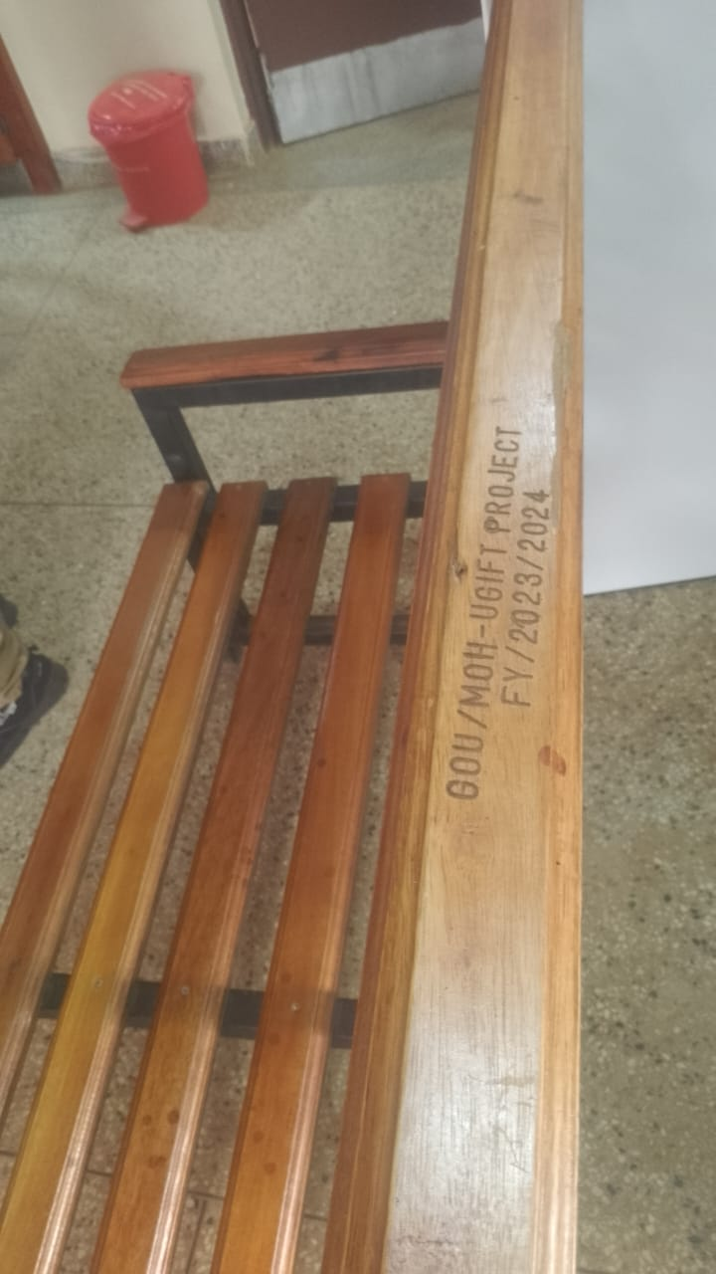
PEDIATRIC BEDS | 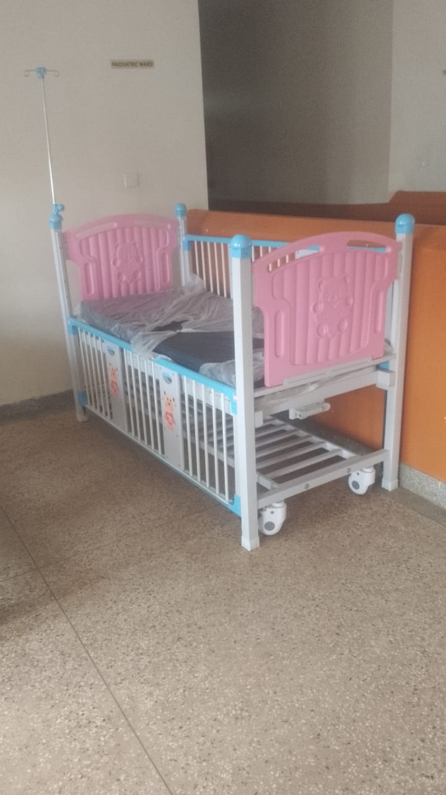
BABY COTS  NOT ENGRAVED | 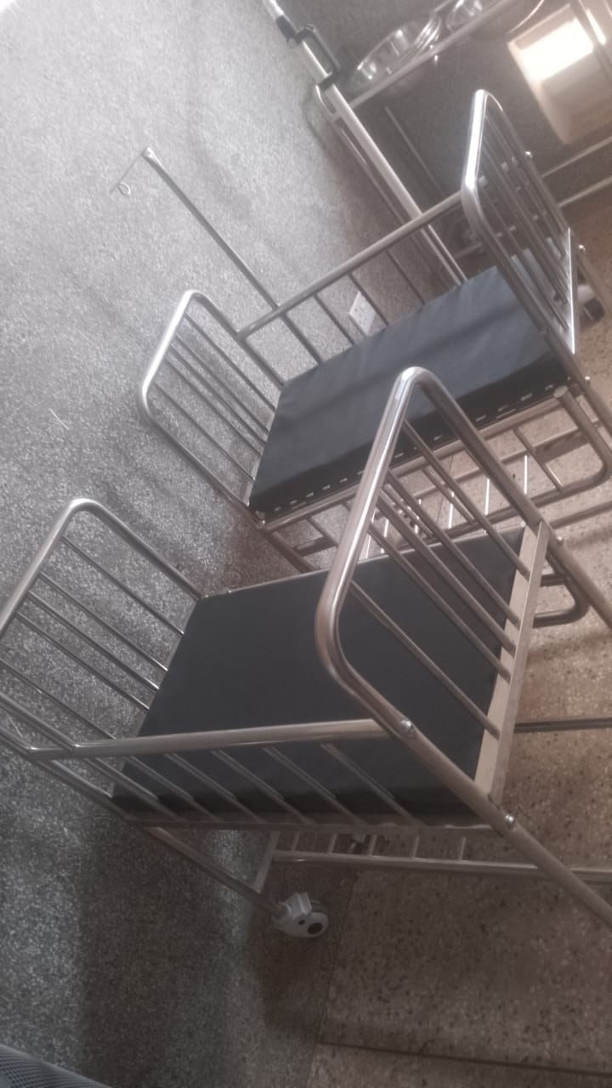

SCHOOL VERIFICATION CHECKLIST

